Commemoration of Martin Luther (Birth)
November 10
Observed November 13, 2016
by Lawrence R. Rast Jr., President and Professor of Historical Theology at Concordia Theological Seminary in Fort Wayne, Indiana, and Chairman of the Commission on Theology and Church Relations of The Lutheran Church—Missouri Synod

Introduction to the Sermon
Martin Luther changed history, and 500 years later we’re still talking about it. But if you had been in the little town of Eisleben on November 10, 1483, you probably wouldn’t have even noticed his birth. There really was nothing special about Martin and his family that would have caught your attention. But God uses ordinary people to do extraordinary things. God was shaping Martin Luther for service. Thunderstorms, theses, and his bold words at Worms in 1521: “I cannot do otherwise, here I stand, may God help me, Amen” (Luther’s Works 32:113). All worked together to bring the Gospel of Jesus Christ to light and to enable the Reformation of the Church to go forward. Insisting before the most powerful people of his age on the Scripture’s teaching that we sinful human beings are “justified by faith apart from works of the law” (Romans 3:28), Luther in time came to be known as the “third Elijah.” He would have spurned the title, hoping that people, in the end, would talk not about him but focus only on Jesus. We give thanks this day for Luther’s faithful service, but we are even more thankful for the message that we are justified by grace through faith because of Christ, a message Luther recovered for the Church.
Sermon Preparation Notes
1. On Remembering
For an interesting perspective on memory, see “Why We Remember, Why We Forget,” National Geographic (November 2007). This article describes the tragedy of not having a memory this way: “Without a memory, EP [the initials of the man who is the subject of the article] has fallen completely out of time. He has no stream of consciousness, just droplets that immediately evaporate. If you were to take the watch off his wrist—or, more cruelly, change the time—he’d be completely lost. Trapped in this limbo of an eternal present, between a past he can’t remember and a future he can’t contemplate, he lives a sedentary life . . .” (p. 37).
“Trapped in the limbo of an eternal present . . .” Now think about that for a minute. To lose one’s memory is to lose one’s freedom. But the Son has come to set us free. Recalling our past frees us to embrace our future.

2. Luther Quotes
“Then I began to comprehend ‘the righteousness of God’ through which the righteous are saved by God’s grace, namely, through faith; that the ‘righteousness of God’ which is revealed through the Gospel was to be understood in a passive sense in which God through mercy justifies man by faith, as it is written, ‘The just shall live by faith.’ Now I felt exactly as though I had been born again, and I believe that I had entered Paradise through widely opened doors. I then went through the Holy Scriptures as far as I could recall them from memory, and found in other parts the same sentence. . . . As violently as I had formerly hated the expression ‘righteousness of God,’ so I was now as violently compelled to embrace the new conception of grace, and, thus for me, the expression of the Apostle really opened the Gates of Paradise.”
“I beg not to have my name mentioned, and to call people, not Lutheran, but Christian. What is Luther? The doctrine is not mine, nor have I been crucified for any one. St. Paul would not suffer Christians to be called after Peter, but only after Christ. Why should I—miserable piece of corruption that I am—have this honor, that the children of Christ should be called after my abominable name? No, no, my dear friends; let us abolish party names, and be called Christians after Christ, whose doctrine we have.”
3. Magdeburg Confession Quotes
“There can be no doubt that God by His great kindness raised up Dr. Martin Luther as a third Elijah, in order that he might reveal in these last days (according to His published prophecies) the Man of Sin, the Son of Perdition, the Antichrist, ruling in Rome in the Temple of God; likewise, to destroy him by the Spirit of the mouth of Christ, and to rebuild the entire doctrine of His Son. Therefore, since God had raised Luther up for this exceedingly difficult task, He also equipped him at the same time by the Holy Spirit with a superior understanding of the sacred Scriptures, with singular strength of faith in his heart like an immovable rock, and with lively skill in his mouth for teaching and arguing.”
“The cause of the prophets, of Christ, and of the apostles first truly began to emerge in oppression, and they themselves after their death began to be more glorious. For this purpose God placed His prophets and apostles, that they should go forth bearing fruit and that their fruit should remain, and that He himself might display power in weakness, life in death, glory in shame, His planting in their uprooting.”
“And so Luther, although dead, both lives forever himself and the fruit of his work, as if it were a dead man, also lives, and shall live, and shall flourish in all ages and among still more nations.”
4. Three Examples of Der Lutheraner Mastheads (from earlier to later)

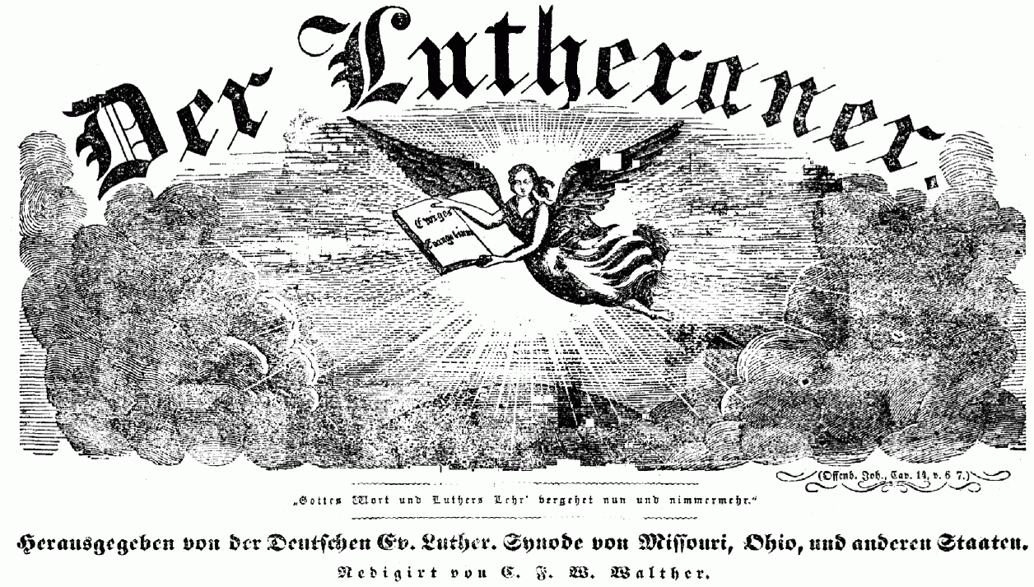

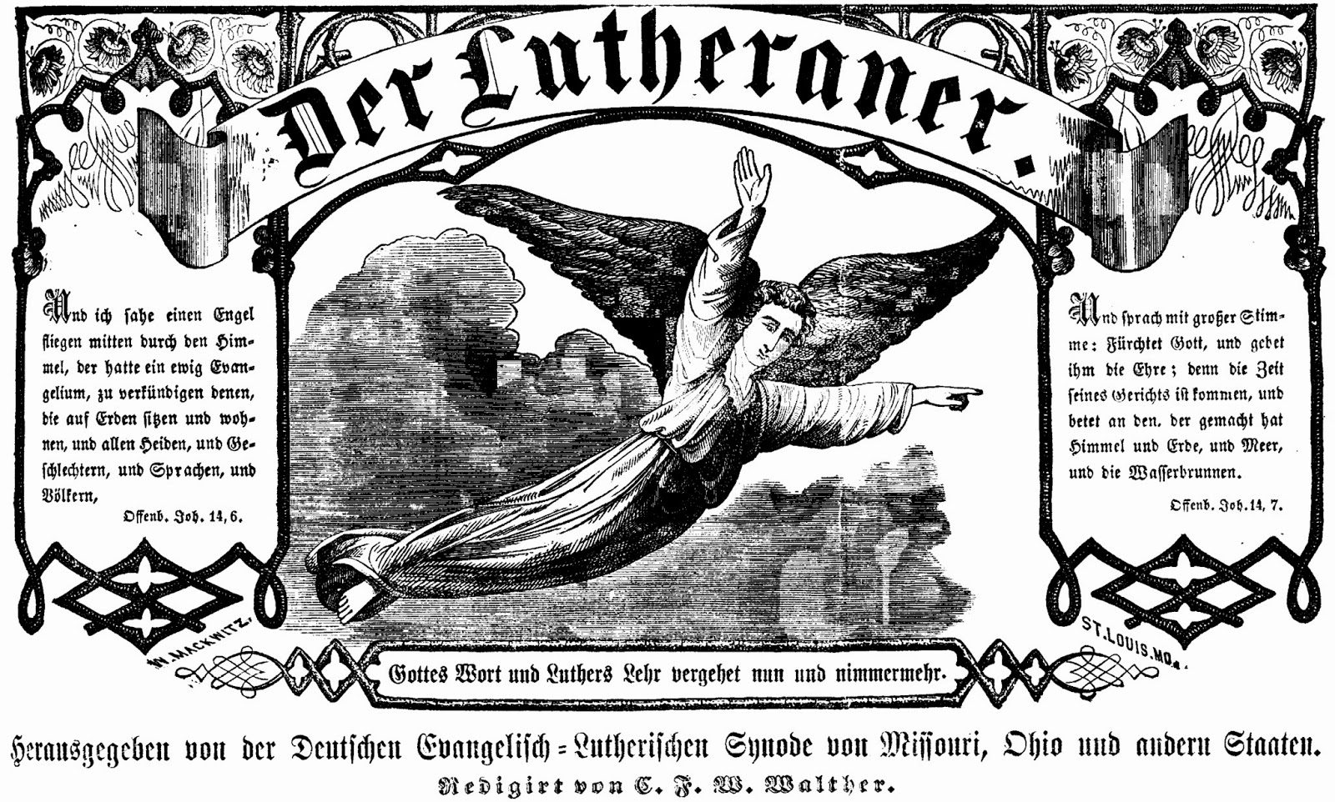

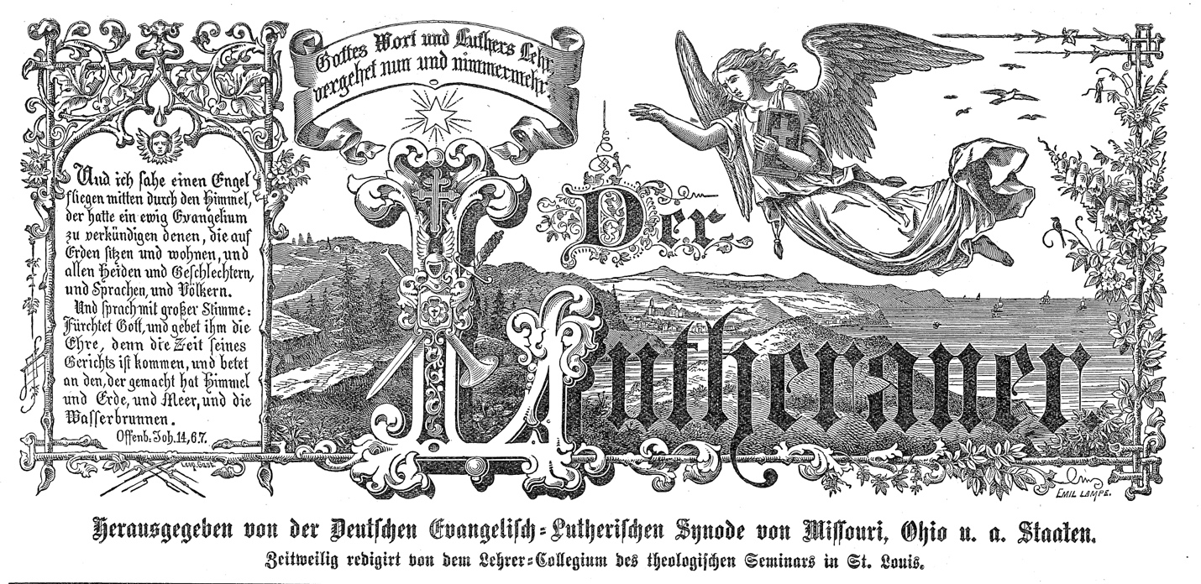

Sermon
Remembering Our Leaders
(Hebrews 13:7)

Built on the Rock the Church shall stand
Even when steeples are falling.
Crumbled have spires in ev’ry land;
Bells still are chiming and calling,
Calling the young and old to rest,
But above all the soul distressed,
Longing for rest everlasting. (LSB 645, st. 1)

On November 10, 1483, the Church was struggling. The Bible was generally not read, and even where it was, it was not well understood. Law and Gospel were largely confused. People longed for rest, but were driven to their good works. But their good works never seemed sufficient to achieve peace with God—and indeed they were not.
On November 10, 1483, Martin Luther was born. And though his birth was not a noteworthy event even in the little town of Eisleben, Germany, in time this man would open the pages of the Bible and help the Church recapture its central teaching: that we are saved by grace through faith because of Christ.
It is good for us to remember. History and memory hold the Church together. The Gospels themselves are a narrative that recall the work of Jesus for us. Without knowledge of Christ’s work, faith cannot exist. Just so, without a vivid memory of the past, the ties holding us together as the people of God are severed. The story of Jesus is told by human beings—yes, often clay jars that are easily broken—but simple human beings nonetheless.
And so today we commemorate God’s work through His humble servant Martin Luther. We do this not for Luther’s own sake; he is not the point. We do so to remember how faithful God is in maintaining His Church and keeping the promise that was given to us by Christ Himself: “The gates of hell shall not prevail against [Christ’s Church]” (Matthew 16:18).
It Was All about Jesus
Martin Luther was a simple person. Today, it is hard for us to think of him like that, given that we know what an enormous role he would come to play in world history. But he was born into a family of modest means in completely unremarkable circumstances.
Luther’s early years are full of stories of developing character and, at times, extraordinary events. We all know the story of the thunderstorm that drove him into the monastery. “Help me, St. Ann, and I will become a monk,” he cried, fearing for his life.
But momentous, life-changing events such as this, as significant as they are, are not what really set Martin Luther apart. What set him apart was his deep love for the Gospel, which he discovered only later in his life. After years of struggling to achieve a righteousness of his own, the Holy Spirit opened the Scriptures to him and showed him that the righteousness of God was not something that Luther merited, but was, in fact, something that Christ had won for him—and for us all—by grace. This was truly good news, great news, then and now. For the Reformation is still all about Jesus!
And Jesus is what we all still need. Historians tell us that Luther’s world was steeped in ignorance and superstition. Most people had little or no knowledge of God’s Word, because most of them could not read, and Bibles were expensive and scarce. While today we have easy access to God’s Word, basic human nature hasn’t changed. We are conceived and born in ignorance and superstition. We deny our sinfulness and our rebellion against God. But in that purposeful forgetting of our own past, we show that people today are spiritually really no different than at Luther’s time.
When Martin Luther rediscovered the Gospel, he sought to reform the Church—not overthrow it. He was not seeking to start a new church. He wanted simply to reform the existing Church, to draw it back to the pure Gospel of God’s grace in Christ. He invited church teachers and leaders to discuss these vital questions.
From tiny Wittenberg, off the beaten path in Germany, grew a movement that has not stopped, a confessing movement that seeks always to underscore these truths of God’s Word: We are freed from all sins and guilt solely by the grace of God, which is in our Lord Jesus Christ. We receive forgiveness of sins, life, and salvation simply by believing this good news. Sola gratia! Sola fide! Sola Scriptura! Solus Christus! By grace alone! By faith alone! By Scripture alone! Because of Christ alone!
And so Luther pointed only to the One of humble and miraculous birth, Jesus Christ, true God and true man. Luther preached nothing else but Christ, “who for us men and for our salvation came down from heaven and was incarnate by the Holy Spirit of the Virgin Mary and was made man” (Nicene Creed).
And so today we look only to Christ. We know, as St. Paul teaches us, that no human being is justified by works of the law. Don’t look to the world; don’t look at the strength or weakness with which you believe; don’t look to the things you do—including your church attendance; don’t look to the good works you do for your neighbor; don’t even look in your heart. Looking to ourselves only shows us that we have sinned and fallen short of the glory of God, that we earned God’s displeasure, anger, and wrath. We will find no comfort there, no forgiveness there, only bondage in sin.
Look to Christ and Him alone. Christ truly is your comfort, hope, and joy. See that He has done all things well for you. He has earned God’s favor. See how He has kept the Law in our place. See how He has earned heaven. See that Jesus alone, by His suffering and death on the cross, appeased God’s anger and turned away His wrath. See that He does all this for you, in your place. By His work alone we are saved. Jesus, the Son of God, has set you free. And if the Son sets you free, you are free indeed! (cf. John 8:36).
The Third Elijah
God did a great work in the Reformation, but it is a work that is never done. “Time marches on,” and therefore we must never become complacent. A little more than four years after Martin Luther’s death on February 18, 1546, a group of his followers fixed their signatures to one of the more significant, yet lesser-known, documents in the Lutheran tradition. “The Magdeburg Confession” (April 13, 1550) identified Luther as God’s own “prophet,” the third Elijah, who had recovered the scriptural confession of Christ crucified and risen again.
There are good reasons people made the connection between Elijah and Luther. In the biblical narrative (1 Kings 17–21; 2 Kings 1–2), Elijah appeared from nowhere to challenge the religious status quo. Martin Luther did the same. Elijah was outspoken and confronted the religious and political leaders with their departure from God’s will. He bluntly told King Ahab that he had broken the laws of Moses in confiscating his subjects’ inherited property. He challenged the false prophets of Baal. He spoke directly with courage and conviction to those who were persecuting the faithful and proposing all sorts of false religious beliefs and practice.
Martin Luther did the same. At Worms, Luther stood before the Holy Roman emperor himself and refused to deny what he had learned from the Scriptures. “Unless I am convinced by the testimony of the Scriptures or by clear reason, I am bound by the Scriptures. . . . I cannot and I will not retract anything. . . . I cannot do otherwise, here I stand, may God help me.”
Further, Luther also reminded people of the second Elijah, John the Baptist. John’s message was simple and straightforward: repent and believe the Gospel. When Martin Luther posted his Ninety-Five Theses on October 31, 1517, the first one read: “Our Lord and Master Jesus Christ, when He said Poenitentiam agite (“do penance”), willed that the whole life of believers should be repentance.”
Luther—better yet, God through Martin Luther—began the Reformation by reminding people that the life of the Christian should be one of continual repentance and faith. And both John and Luther pointed only to Christ as the Lamb of God who takes away the sin of the world. The Lutheran Reformation was about Jesus Christ. It’s still all about Jesus!
Conclusion
For many years, the old German periodical of the Missouri Synod, called Der Lutheraner, had as its theme the German words “Gottes Wort und Luthers Lehr vergehet nun und nimmermehr.” In English we might render this: “God’s Word and Luther’s doctrine shall endure now and forever.” That’s a big claim. But, again, it is not because Luther said any of this that we are remembering today. It is because what Luther taught was drawn from the pure font of God’s Word. Luther’s role was to recover what had been confused and to uncover what had been obscured. And that was simply the Gospel of full and free salvation won by Christ’s suffering, death, and resurrection.
So it is unsurprising that Der Lutheraner also featured on its front page the picture of an angel and the text of Revelation 14:6–7, which reads: “Then I saw another angel flying directly overhead, with an eternal gospel to proclaim to those who dwell on earth, to every nation and tribe and language and people. And he said with a loud voice, ‘Fear God and give Him glory, because the hour of His judgment has come, and worship Him who made heaven and earth, the sea and the springs of water.’ ”
Already at the time of Luther’s death, some, including his pastor Johannes Bugenhagen, saw the fulfillment of Revelation 14:6–7 in Martin Luther—again, not because he was less of a sinner or greater in God’s eyes than others, but because of his bold proclamation of Jesus Christ as the one who has won forgiveness of sins for us, “not with gold or silver, but with His holy, precious blood and with His innocent suffering and death.”
That is why we remember the birth of Martin Luther today. God used this humble man from out-of-the-way Wittenberg to shine the light of the Gospel brightly into his day and, thankfully, into ours as well. It is good that we remember Martin Luther’s birth. It is even better that we remember and believe in the One to whom Luther always pointed: Jesus Christ, our Savior and Lord.

Grant, then, O God, Your will be done,
That, when the church bells are ringing,
Many in saving faith may come
Where Christ His message is bringing:
“I know My own; My own know Me,
You, not the world, My face shall see.
My peace I leave with you. Amen.” (LSB 645, st. 5)

~~~~~~
Acknowledgments
Published by Concordia Publishing House
3558 S. Jefferson Ave., St. Louis, MO 63118-3968
1-800-325-3040 • www.cph.org
Copyright © 2015 The Lutheran Church—Missouri Synod
Other than downloading this resource for personal, Bible study, classroom, or congregational use, other usage is prohibited. No part of this material may be transmitted in any form or by any means, electronic, mechanical, recording, or otherwise, without prior written permission of Concordia Publishing House.
Scripture quotations are from the ESV Bible® (The Holy Bible, English Standard Version®), copyright © 2001 by Crossway Bibles, a publishing ministry of Good News Publishers. Used by permission. All rights reserved.
The quotation from Luther’s Works is from the American Edition (56 vols.; St. Louis: Concordia Publishing House and Philadelphia: Fortress Press, 1955–86).

E. G. Schwiebert, Luther and His Times (St. Louis: Concordia, 1950), 286.
“Why the Name Lutheran?” Theological Monthly 1, vol. 6 (June 1921): 174.
Matthew Colvin, trans., “The Magdeburg Confession: Preface,” in The Magdeburg Confession: 13th of April 1530 AD (CreateSpace Independent Publishing Platform, 2012), 3.
Matthew Colvin, trans., “The Magdeburg Confession: Preface,” in The Magdeburg Confession: 13th of April 1530 AD (CreateSpace Independent Publishing Platform, 2012), 5.
Matthew Colvin, trans., “The Magdeburg Confession: Preface,” in The Magdeburg Confession: 13th of April 1530 AD (CreateSpace Independent Publishing Platform, 2012), 5.
George W. Forell, ed., Career of the Reformer II, Luther’s Works (Philadelphia: Muhlenberg Press, 1958), 32:112.
Martin Luther, Disputation of Doctor Martin Luther on the Power and Efficacy of Indulgences: October 31, 1517, electronic ed. (Bellingham, WA: Logos Bible Software, 1996).
Explanation of the Second Article, based on 1 Peter 3:18–19. From Luther’s Small Catechism with Explanation (St. Louis: Concordia, 1986, 1991).

